Assignment No: 5

Name: Chirag G. Padsala.

CWID: 805613197.

CPSC-558.

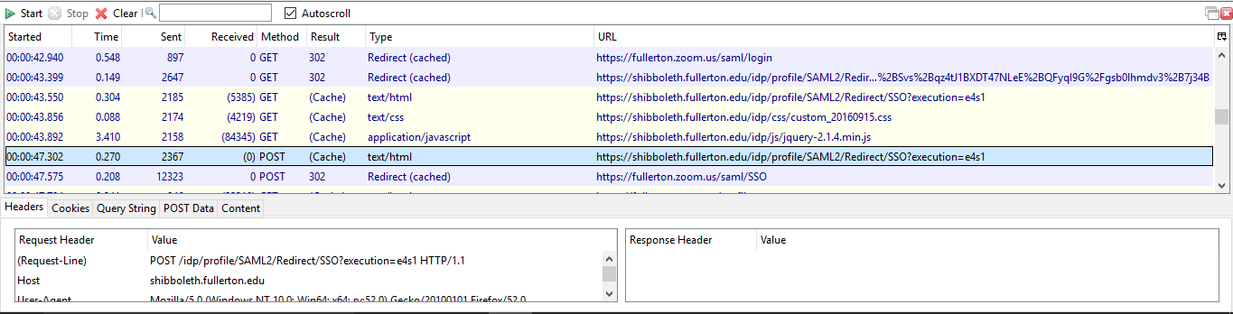1. Images output of traffic and Shibboleth:

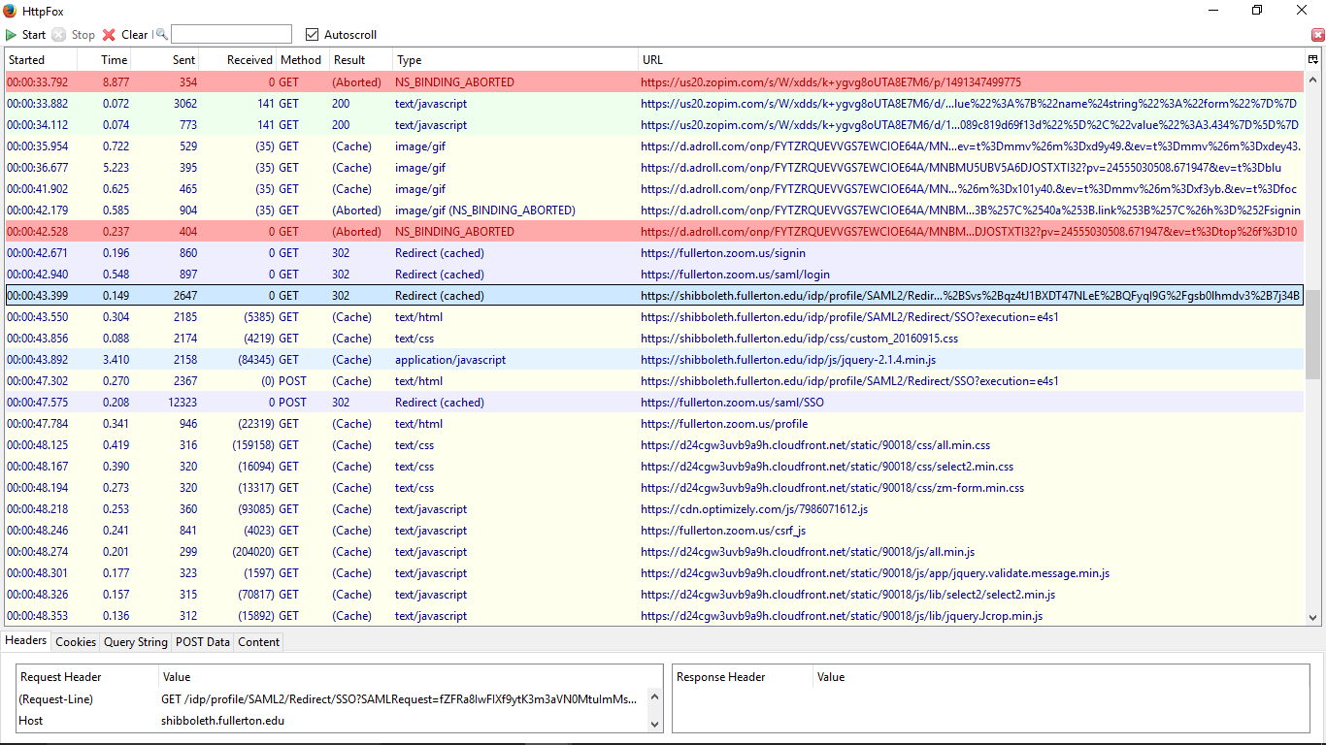

2. SSO:

By learning the Shibboleth Http packet, it can be understood it uses SAML2 SSO.

SAML 2 stands for **Security Assertion Markup Language 2.0**, it’s a version of SAML. It is a standard for exchanging data in the form of information for authentication and authorization between different security domains.

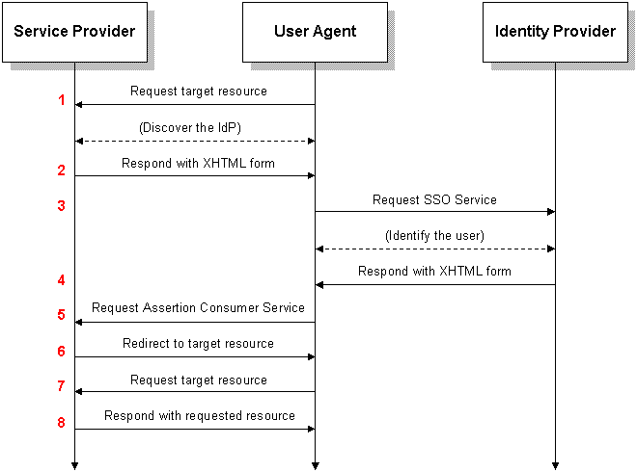

Figure: SAML 2.0 Web Browser SSO (Wikipedia).

References:

<https://en.wikipedia.org/wiki/SAML_2.0>

<https://addons.mozilla.org/en-Us/firefox/addon/httpfox/>